

Call for Expressions of Interest
“Modernisation of Créac’h Lighthouse”



Table of Contents
I – CONTEXT 3
I.1 – Mercury removal 3
I.2 – A search for a technical solution 3
I.3 – Governance 4
II – DESCRIPTION OF THE STRUCTURE 5
II.1 – Créac'h Lighthouse, a piece of maritime signalling infrastructure and listed historic monument 6
II.1.a – General operation of the beaconing system 6
II.1.b – Preservation of historic monuments 6
II.1.c – Historical overview 6
II.2 – Overview and operation of the rotation system 7
II.2.a – Brief description 7
II.2.b – Rotation system 8
II.2.c – Existing heritage elements 10
II.2.d – Virtual tour of the facility 11
II.3 – Current maintenance 11
II.4 – Access and site constraints 11
II.5 – Reference documents and plans 12
III – RULES OF THE CEI 13
III.1 – Consultation outline and schedule 13
III.2 – Objectives 14
III.3 – Heritage and technical requirements 16
III.4 – Terms and conditions 17
III.4.a – Candidate eligibility 17
III.4.b – Confidentiality 17
III.5 – Phase 1 – Preliminary selection of candidates / projects 17
III.5.a – Application procedure 17
III.5.b – Site visit 18
III.5.c – Contents of project applications 18
III.5.d – Project selection criteria 19
III.5.e – Project selection and requests for further information 19
III.6 – Phase 2 – Further development of selected projects 20
III.6.a – Site visit 20
III.6.b – Iterative exchanges 20
III.6.c – Selection of the winner 20
III.6.d – Contractualisation 20
IV – APPENDICES 21
IV.1 – Application 22
IV.2 – Heritage studies 24
IV.3 – Reference documents 24
IV.4 – Information relating to asbestos and lead 28
IV.5 – Organisations and points of contact 28

I – CONTEXT

I.1 – Mercury removal
The two-tier Fresnel optic at Créac'h Lighthouse on Ushant Island uses a historical rotation system, based on the principle of a structure floating on a bath of mercury contained in a tank. Mercury is a dangerous substance, classified as a CMR chemical, and a national policy has been enacted to eliminate mercury use in maritime signalling infrastructure. There are large quantities present at Créac'h, given the weight to be supported in rotation, which represents a major issue for government employees and contractors. The facility is classified for environmental protection (ICPE).
Furthermore, the rotation system, which includes the tank containing the mercury, dates back to 1938 and is showing signs of ageing, raising fears of a mercury leak. Such an incident could lead to pollution of the confined environment, or even exterior contamination, exposing personnel to a high level of risk and complicating all operations. The light signal to mariners would also be interrupted.
In this context, and in line with France’s national mercury elimination strategy, the public authorities have launched a nationwide phase-out initiative. The case of Créac'h has been identified as a priority, particularly after a leak from a drain valve in autumn 2024. All of the following aims to meet the urgent need to remove the mercury from Créac'h as quickly as possible.

I.2 – A search for a technical solution
Créac'h Lighthouse is part of the beaconing system around Ushant and thus contributes to maritime safety. It is also listed as a historic monument. The Ministry for the Sea is therefore launching a Call for Expressions of Interest (CEI) for a plan to remove the mercury that takes into consideration the heritage and maritime safety issues specific to Créac'h.
Although simple, inexpensive solutions currently exist that could maintain the maritime signalling service at a sufficient level to meet the needs of 21st-century navigators, there is no immediate technical solution on the market that would meet the requirements and wishes described below and that takes account of the technical and heritage requirements that the French government wishes to impose, especially to meet the expectations of society for this unique and singular structure.
The aim of this Call for Expressions of Interest (CEI) is to bring forward innovative proposals that meet maritime signalling requirements while respecting heritage considerations. The CEI does not include the emptying of the mercury tank. This operation will be carried out beforehand by the Interregional Directorate for the Sea - North-Atlantic Channel-West (DIRM NAMO).

I.3 – Governance
The overall process is organised by the DIRM NAMO under the coordination of the Prefect of Finistère. The latter chairs a Steering Committee, which will meet at key points in the process to orchestrate the decisions made by the Ministry for the Sea, which manages Créac'h Lighthouse.
This committee is supported by the technical work of a project team.
The Steering Committee chaired by the Prefect of Finistère is responsible for consultation and implementation of the guidelines laid down by the Ministry. It will select the winning team or teams that it deems appropriate to present to the site manager to be contracted.
It is composed of elected representatives (Mayor of Lampaul Ouessant, MP for the 6th Constituency of Finistère, Representative of the President of the Departmental Council of Finistère [CD29]), representatives of government departments (Prefecture of Finistère, DIRM NAMO, Brittany Regional Directorate of Cultural Affairs [DRAC], Finistère Delegation for the Sea and Coastline [DML]) and local associations (Ouessant Vent de Bout', Sauvegarde du Feu du Créac'h).

Under the direction of the DIRM NAMO, the project team will work to propose and draft a framework for the CEI (rules, documents to be submitted, criteria for evaluating team / project pairs, provisional schedule and milestones), analyse the applications and monitor the projects and candidates at the various stages.
It reports to the Steering Committee.
It is composed of decentralised government departments (Brittany DRAC, DIRM NAMO, Finistère DML), the CEREMA and associated bodies (Pôle Mer Bretagne, CD29, Museum of Lighthouses and Beacons), as well as the Chief Architect for Historic Monuments (ACMH).

II – DESCRIPTION OF THE STRUCTURE
This chapter presents Créac'h Lighthouse in its current configuration. It describes the main components of the optic system, their functional operation and their mechanical articulation.
The optic of the Créac'h lantern has two tiers:
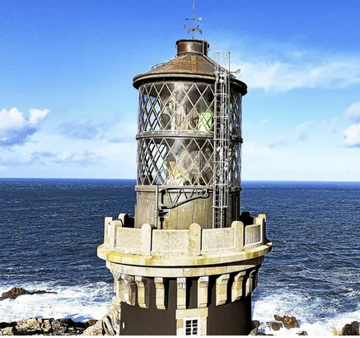
They house the optic, made up of four double lenses:
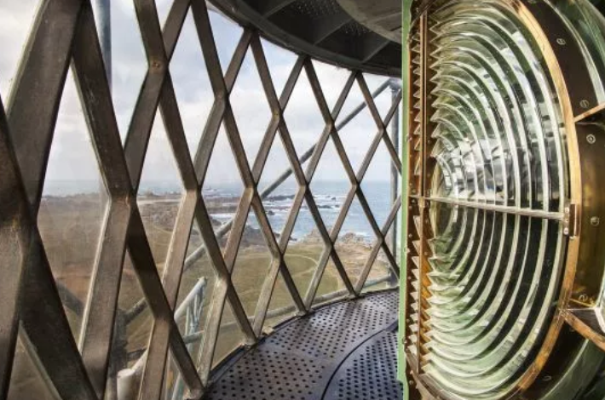

II.1 – Créac'h Lighthouse, a piece of maritime signalling infrastructure and listed historic monument

II.1.a – General operation of the beaconing system
France's maritime signalling system is based on a series of lights, lighthouses, beacons, buoys and virtual aids designed to help navigators determine their position, and thus ensure safe navigation. These are called navigational aids.
The system is organised according to the technical and organisational principles laid down by the International Association of Marine Aids to Navigation and Lighthouse Authorities (IALA) and provides clear, consistent and reliable information to guide mariners along the coasts and around ports.
Navigational aids make it possible to determine positioning in conjunction with bearings, signal hazards and indicate navigation channels. By day, they are visible and identifiable thanks to their shape and colour.
At night, or when visibility is reduced, their luminous signals provide the same services. They use a coded light sequence, a range adapted to the sector, and optical and electrical equipment ensuring regular, identifiable emission.
These facilities must comply with IALA technical recommendations, chart information from the Naval Hydrographic and Oceanographic Service (SHOM) and the administrative ruling that led to their creation. This requirement for compliance is laid down in France by the Transport Code and also specifies the acceptable rate of unavailability for each of these aids. This rate determines the robustness and reliability of the technical systems chosen to perform the function.
French law specifies the technical characteristics of maritime navigational aids under the Order of 30 November 2017, which defines the maritime beaconing system and its nautical and technical reference framework, amended by the Order of 10 December 2021.

II.1.b – Preservation of historic monuments
Créac'h Lighthouse is protected as a Historic Monument by a classification order dated 23 May 2011. Under French law, classification represents the highest level of heritage protection, aimed at preserving as much as possible of the original features of the monument in question. All conditions relating to protected monuments are governed by the French Heritage Code.
As such, Créac'h Lighthouse is a building for which all work must be approved by a request for authorisation from the Brittany DRAC. In the case of listed buildings owned by the State, the contracting authority responsible for the design and execution of the project must be the Chief Architect for Historic Monuments (ACMH) with territorial jurisdiction.
In the case of Créac'h Lighthouse, protection as a Historic Monument testifies to its major importance in the history of maritime architecture and highlights the quality of the structure and all its equipment. It is the link between historic architectural knowledge and the quest for technological innovation. Its lantern and lens are the symbol of this, a true technical feat. It will therefore be essential to take all these factors into account when planning future projects for the monument.

II.1.c – Historical overview
In the late 17th century, the first lighthouse was built on the island of Ushant by Sébastien Le Prestre, Marquis of Vauban. It is located on Stiff Cliff, the highest point on the island.
A century and a half later, in 1856, the island's municipal council wanted to build a second lighthouse, with greater reach. Construction was completed in 1863. The lighthouse was converted to electricity in 1884. Three years later, a new lens was installed, following the principles of Augustin Fresnel. In 1901, the optic was modified, operating on a mercury bath.
After being exhibited at the 1937 World’s Fair, a new lantern was installed between 1938 and 1939. At the time, Créac'h Lighthouse was the most powerful in the world. The optic system was made by BBT and to rotate, it used a mercury bath once again.
Since then, Créac'h Lighthouse has been regularly maintained and only a few minor modifications have been made, to modernise the lighting system. Restoration work on the tower and ancillary buildings is currently being carried out by Marie-Suzanne de Ponthaud, ACMH, on behalf of the Departmental Council of Finistère (CD29) as part of the modernisation of the Museum of Lighthouses and Beacons.

II.2 – Overview and operation of the rotation system

II.2.a – Brief description
Créac'h Lighthouse is part of a navigational aid system consisting mainly of various lighthouses, towers and buoys. It helps to ensure safe navigation around Ushant Island, particularly during landings. It currently has a nominal range of 30 nautical miles (M), which was deemed necessary for service in 1939. Navigators can recognise it among other beacons in the area thanks to its characteristic signal of two white flashes every ten seconds.
The building rises to a height of 54 m and is made up of an ashlar masonry tower topped by a lantern (11 m high), which houses the optic system that produces the light signal for maritime signalling. The lantern is made up of three levels:
- The ground floor, enclosed and surrounded by a gallery walkway, which can be accessed by a spiral ashlar staircase,
- Two upper floors, enclosed by glass with a steel structure, which can be accessed by a narrow metal staircase.
The two flashes that can be seen every 10 seconds by mariners are produced by an all-horizon rotating light (360°) which emits eight white beams of light, coming from four light source/lens pairs (the light sources currently used are 1000W metal-halide lamps).

II.2.b – Rotation system
The rotation system consists of two plates laid one over the other, each bearing two white light sources paired with two double Fresnel lenses. The two connected plates sit on a float supported by a volume of mercury contained in a fixed tank and rotate around a vertical axis.
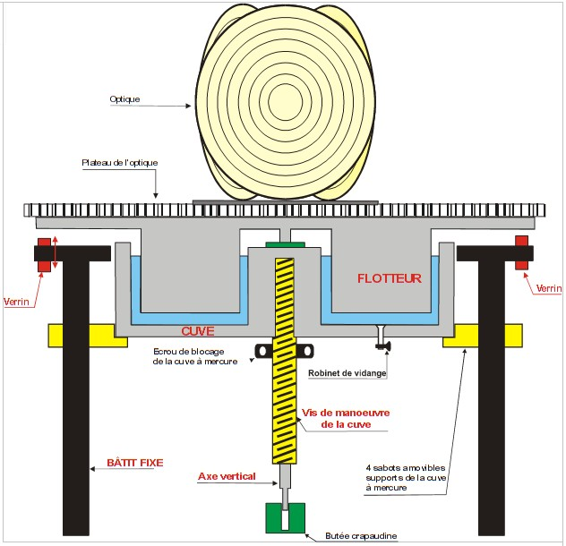
Schematic diagram – lighthouse optic on mercury bath
The mobile unit with the two plates that hold the optic is kept in motion by two electric motors that alternate (one per day). The rotation mechanism is guided by two rings of annular ball bearings positioned at the level of each plate.
It takes 40 seconds for the plates to complete a full revolution, which generates a white light with two flashes every ten seconds.
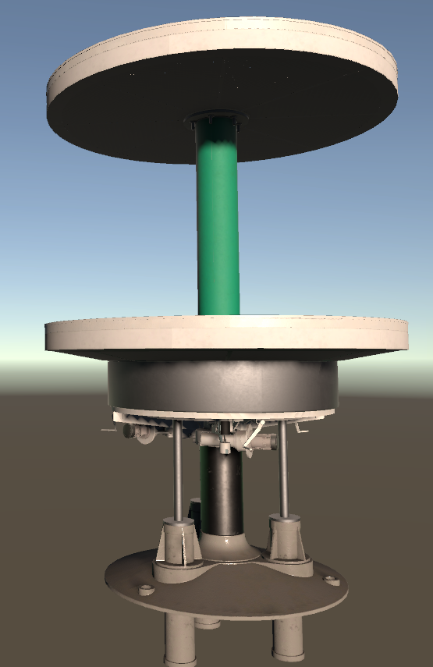
3D image of the tank/double plate system – Créac'h Lighthouse

Main mechanical support and rotation elements:
The rotation shaft is a cast-iron column that was put in place before the lantern was mounted (see above and photos in the reference documents). The two plates are connected by a cast-iron strut and rotate around this fixed column, which runs through the lantern vertically.
The two rotating plates are made of steel, in a circular shape. On each plate, two lens/light source pairs are positioned opposite each other.
The mobile unit (upper and lower plates + strut + float) rests on a mercury bath contained in a circular tank. The mercury (1.1 tonnes, or around 85 litres) significantly reduces friction.
In operation, the tank is secured at three points embedded in the column.
The plate supporting the tank can be moved by three vertical hydraulic cylinders, to raise and lower the tank for emptying. However, the hydraulic system is no longer currently operational.

Identification of fixed and mobile parts:
Part | Status
Tank | Fixed
Column | Fixed
Plates  Strut  Float  Lenses/light sources | Mobile unit

II.2.c – Existing heritage elements
The lighthouse, the lighthouse keepers' housing and the Museum of Lighthouses and Beacons are grouped together in an enclosure with a surrounding wall.
The lighthouse stands 54 m high, consisting of a base, a tower, a crown and a lantern.

The base is built of granite ashlar. On the south-east side, it is pierced by the entrance to the lighthouse. A seven-step staircase provides access.

The tower is built of rubble stone masonry and painted in alternating black and white. It has 19 bays. They correspond to the intermediate landings of the staircase and watch room, located under the lantern. These windows are adorned with stone frames.

The tower is crowned with ashlar. It features a cornice and balustrade, supported by a row of brackets.

The interior of the lighthouse features a granite spiral staircase. The ground floor is paved in granite. The interior walls of the lighthouse are covered in painted cement plaster. There are two grooves in the circular wall at the top of the tower. This is where the counterweights that were used to rotate the lens of the old lantern are housed. Just above is the watch room, adorned with oak panelling, from which the lantern can be accessed via a metal staircase.

The current lantern was installed on the gallery above the crown in 1939. It has three levels (the first with solid walls and an access door to the passageway, then two fully glass levels). The mercury tank, used to rotate the lens, is located on the 1st level of the lantern. Levels two and three are enclosed by a wall of windows (the lantern) with a bronze diamond-shaped metal frame. The four Fresnel lenses are distributed across these two levels. They are placed on two plates that pivot around a central axis. Each lens is illuminated by a metal-halide lamp and diffuses two beams of light.
The lighthouse's visual signature is made up of eight beams of light, which are an important heritage feature but are not listed.

In general terms, given that all existing elements are protected, they should be preserved as much as possible, both in terms of the building’s silhouette and all structural and architectural elements (doors, railings, panelling, etc.) and in terms of the lighthouse's existing equipment, such as the Fresnel lenses and the rotating plates.

II.2.d – Virtual tour of the facility
A virtual tour of the lantern and rotation system will be made available by the DIRM NAMO at the request of candidates that are able to demonstrate their credibility.
Created by VIRTUALYS, it is designed to allow candidates to understand the structure more quickly and easily.
However, it should be noted that there may be discrepancies between the model and the actual structure. Incomplete archival resources and a lack of documentation of changes to the facility since it was built mean that the virtual representation is not an exact replica of what is there.
To understand the mechanisms, candidates can refer to the various elements of this virtual tour:
- An interactive 3D view offering a virtual tour of the lantern,
- An executable program detailing the assembly of the mechanical components of the rotation system, and the kinematics for lowering the mercury tank. Information about the parts (dimensions, constituent materials) are given for information purposes only, subject to the availability of archival materials.
A modelling source file that can be used with the free software program Blender can also be provided. This allows candidates to isolate parts and refine their understanding of systems and mechanisms. Exports can also be made to other software.

II.3 – Current maintenance
The table below identifies the equipment subject to scheduled preventive maintenance for the structure in its current configuration (maritime beaconing light signal emitted by Fresnel lenses rotated on mercury bath).
These operations are generally on an annual basis, enabling a range of preventive maintenance to be carried out using limited human and material resources, at a relatively low cost.
Equipment | Target  frequency | Resources | Estimated cost/year
Lubrication of plate motor | Annual | 2 agents – 1 day | €500.00
Lubrication of bearings | Annual | 2 agents – 1 day | €500.00
Replacement of light sources (x4) | Annual | €1300 VAT included (€300 per light source + labour and logistics) | €1,300.00
Emptying of mercury tank | 20 years | 4 agents – 5 days + PPE | €14,150.00

The mercury system was last completely emptied in 2005.

II.4 – Access and site constraints
The lighthouse is located on an island, which restricts access for personnel and the supply of materials and equipment, but also limits the resources and equipment available on site. This also means that there are additional costs involved in setting up a living base and staff for a long period of construction.
Type of difficulty | Details and comments
- Installation of the rotation system | - Historically, the rotation mechanism was installed while the lantern was still open to the elements, which creates major geometric constraints for work on the system.
- Handling | - The optic is very fragile – must be handled carefully when dismantling, heavy to handle as a whole
- Contamination | - Presence of mercury (tank), lead (paint) and asbestos (optic seals)
- Hydraulics | - The tank jacks are out of service – lifting/lowering must be undertaken manually, by reconditioning existing jacks or installing a specific external lifting system
- Site access | - Island, distance from slipway
- Access to the lantern | - Narrow, curved staircases – gallery walkway at the top
- Transport/lifting | - Constraints linked to the island location – few public works vehicles on site  - A winch is located on the gallery walkway and can be made available to candidates
- Electricity | - Power supply in place (see §Technical requirements)
The dimensions are shown on the plans in the reference documents for the site and can be retrieved from the 3D modelling files.

II.5 – Reference documents and plans
Existing documentation has been identified, classified and ordered to make it easier to understand how Créac'h Lighthouse works and support the studies. The reference documents for the site will be made available by the DIRM NAMO at the request of candidates able to demonstrate their credibility.

III – RULES OF THE CEI
This chapter presents the objectives set by the Steering Committee for the Call for Expressions of Interest (CEI), the related technical and heritage framework and the points to note regarding the solutions to be submitted.

III.1 – Consultation outline and schedule
The process of seeking technical solutions through the Call for Expressions of Interest is divided into several phases, which are explained here in general terms. Details regarding what each phase entails and how they are ordered are defined in specific paragraphs below.
Phase 1 is fairly short and open to anyone, subject to the conditions set out below. Candidates are asked to submit relevant and credible projects. During this phase, candidates can propose concepts and projects at various levels of definition: from simple technical ideas to a system available for purchase, and the whole range in between.
At the end of this first phase, a shortlist of candidates will be selected on the basis of multi-criteria analysis. Each project selected for the shortlist will be subject to specific requests for further information and/or clarification of any points as needed. During this phase, candidates may be invited to work together (consortium) to design a solution. This additional work will be carried out in phase 2, culminating in the final choice of solution to be implemented.
Lastly, once the candidate or candidates have been selected, the contract for the chosen solution will be drawn up, after which work on the site can begin.

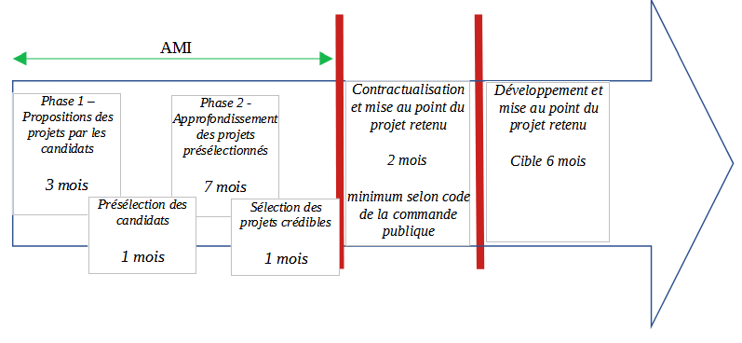

III.2 – Objectives
As stated in section I - Context, the aim of this Call for Expressions of Interest is to bring forward innovative proposals for removing the mercury from Créac’h Lighthouse as quickly as possible, while meeting maritime signalling requirements and respecting heritage issues.

Proposals will be assessed on the basis of their ability to meet the greatest number of objectives in a cumulative manner. The final solution may, where appropriate, be the result of a compromise or a combination of several innovative proposals.

The following objectives set out the areas in which efforts should be focused. Responses will be assessed on the basis of whether all or some of the objectives have been met, as well as other criteria specified in III.5.d - Project selection criteria.

Heritage and technical requirements, particularly regulatory requirements, are essential and covered in section III.3.

The objectives are as follows:
------------------------------------------------------------------------------------------------------------------------
- Maintain a maritime safety facility that complies with nautical requirements (range, signal, availability, etc.) as defined below:
Designation | Requirement
Nominal range | 19M (ref. IALA R0202)
Flash duration | ≥ 50 ms at Imax/2 (0.05 sec)  ≥ 100 ms at Imax/10 (0.1 sec)
Light sequence | Fl2 (10s) (ref. IALA R0110)  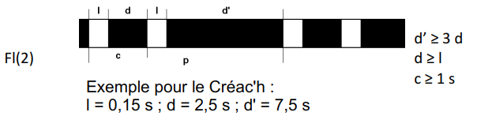
Colour temperature | White, between 2900°K and 6500°K (ref. IALA R0201)
Availability | = 97% (ref. IALA R0130)
Focal plane height | Consistent with the current height of the focal planes integrated into the volume of the lantern
- Ensure that the eight rotating beams remain simultaneously visible from the foot of the lighthouse:
Designation | Requirement
Light signal | Eight light beams grouped in pairs, rotating at a constant speed of 1.5 rpm (1 revolution in 40s), visible from the foot of the lighthouse
Angles between light beams | 22.5° between two paired beams,  78.5° between two pairs of beams
- Preserve the entire exterior silhouette of the lighthouse. No significant modification to the volume of the tower, the gallery or the lantern will be accepted,

- Preserve all historical elements, such as the existing Fresnel lenses and plates,
- Achieve a range equal to or greater than nautical requirements, between 19M (minimum) and 30M (current range),
- Keep the Fresnel lenses in place, and if possible the existing plates as well,
- Reuse the historical optic for signal production,

- Maintain the rotation of the plates holding the Fresnel lenses, or the rotation of the lenses themselves,

- Maintain the current mercury tank (drained) or an artefact,

- Preserve the mercury tank’s access area.

The ultimate aim is to maintain the rotation of the optic; however, candidates may also propose innovative solutions that enable a visually similar result to be achieved without rotation of the optic.

III.3 – Heritage and technical requirements
These requirements are imperative for any proposed solution.
Heritage:
Any modification (addition of elements to architectural features, whether by hanging or adding elements above the lantern) must be formally authorised by the DRAC. (Articles L 621-9 and R 621-11 and 12 of the French Heritage Code).
Technical:
The following characteristics are technical requirements that must be respected by candidates:
Designation | Requirement
Service life of the optic system (excluding consumables) | ≥ 50 years for a solution incorporating all or part of the existing optic system  ≥ 20 years for an alternative solution that does not reuse the existing optic system
Service life of critical components (bearings, motors, LEDs, power supplies, etc.) | In line with manufacturers' specifications, with a commitment to the availability of spare parts for at least 20 years
Frequency of routine maintenance operations | Preventive maintenance feasible in one operation lasting one day per year, with certain years subject to increased maintenance operations
Maintenance | Simple preventive maintenance: inspection, replacement of fluids and seals, checking electrical connections  Corrective maintenance: the solution must allow sub-systems to be replaced without completely removing the optic system and at a “reasonable” cost (to be specified by the candidate).
Maintainability | Accessibility: all components subject to maintenance must be accessible without special tools or major dismantling.  Simplicity of design: the system must be designed according to a robust architecture, limiting the number of moving parts and facilitating visual checks.  Technical documentation: complete maintenance file: diagrams, tightening torques, part numbers, intervals, procedures.  Training for agents in the system’s day-to-day maintenance
Electrical power consumption | < 8kW for the whole system  The site’s electrical distribution network is: mains power; 230Vac 50Hz.  The proposed solution must include a connection from the delivery point at the foot of the lighthouse. A cable pathway runs from the foot of the lighthouse, which can be used to route fluids to the higher levels where the light signal is emitted.
Electrical protection | Overvoltage protection.  Personal injury protection through equipotential bonding.  EMC shielding requested.
Light signal start/stop | Automatic depending on external lighting or using astronomical clock  The solution must include a remote start/stop control system.
Actuator control (light sources and/or motors) | Management of impacts on power supply expected (levels, ramps).  Protection against over-consumption.
Automation and embedded intelligence | Integrated monitoring and control of correct operation.  Detection and clear display of operating faults.
Supervision | Information on operating status provided in on/off 0V format.  Remote operation possible.

III.4 – Terms and conditions

III.4.a – Candidate eligibility
“Candidate” - any entity or group of entities that has legal personhood and submits an application to the Call for Expressions of Interest.

Only legally constituted entities may respond to the Call for Expressions of Interest. Applications submitted by companies, associations, government bodies, local authorities, public institutions or any other entity with legal personhood will be admissible.

III.4.b – Confidentiality
All candidates must clearly identify any confidential information in their application.
Subject to third party rights, all confidential information, media and reproductions transmitted by candidates will remain their property until a contract concluded between the candidate and the contracting authority specifies otherwise.
It is expressly agreed that by communicating confidential information, candidates do not grant any licence or right to patents, copyrights or other industrial and intellectual property rights of which they are the holders.

III.5 – Phase 1 – Preliminary selection of candidates / projects

III.5.a – Application procedure
Applicants wishing to submit a project to the CEI must send their application to creach.ami@mer.gouv.fr before the deadline of 22 March 2026.

III.5.b – Site visit
At the request of the candidates and subject to the credibility of the application, a visit may be possible at the end of phase 1, depending on access restrictions at the lighthouse (works in progress). A virtual tour is offered to help answer initial questions about the structure.
A date for an in-person tour will be proposed by the DIRM NAMO, the facility's operator, to candidates who so request.
All candidates will have to make their own way to Créac'h Lighthouse on the island of Ushant.
The tour will take place in accordance with the terms specified by the DIRM NAMO, in particular with regard to health precautions and measures to be taken with regard to access conditions (decontamination work, presence of mercury, etc.).

III.5.c – Contents of project applications
Candidates may submit different levels of response, for example:
- proposal of a technical concept to be adapted to meet the needs identified,
- detailed design study of a system, with a view to consultation with industrial production operators and installation work,
- supply of equipment to meet the needs identified, and possibly services to install the system in the lighthouse

The application form can be found in the appendix.

III.5.d – Project selection criteria
At the end of phase 1, the CEI Steering Committee will select the project or projects judged to be credible to be considered for continuation in phase 2.
This choice will be made on the basis of multi-criteria analysis focusing on the points below. Candidates should ensure that their application includes all the information needed to assess these criteria.
- Compliance with the challenges of the CEI
Does the proposed system meet several or all of the objectives identified in sections III.1 and 2?
Does the proposed system meet the heritage and technical requirements identified in section III.3?
Does the project sponsor demonstrate that the proposed project can be implemented?
- Ability of the candidate to provide the services identified in its application
Does the project sponsor demonstrate its ability to see the project through to completion?
- Estimated cost of the proposed system
Is the full cost of ownership - acquisition, maintenance, end-of-life waste management - of the system for the proposed project explained and documented?
As of the end of phase 1, is the estimate reliable?
Schedule
Is the schedule for deploying the solution (studies and works) proposed by the applicant in line with the objectives of the CEI?

III.5.e – Project selection and requests for further information
At the end of phase 1, a limited number of projects will be selected so that they can be further defined and the final solutions developed in conjunction with the facility operator and various stakeholders.
Each candidate selected will be sent a personalised document setting out the points to be explored in greater depth during phase 2.

III.6 – Phase 2 – Further development of selected projects
Only candidates who have submitted an application in phase 1 may be selected for phase 2.
Multiple projects and candidates may be invited to collaborate on the development of a common solution in phase 2, if this possibility is identified as relevant and accepted by the candidates concerned.

III.6.a – Site visit
A site visit will be organised at the beginning of phase 2 with all candidates selected for this phase. Candidates must attend this tour.
A date will be proposed by the DIRM NAMO, the facility’s operator, to the candidates selected for the further development phase.
All candidates will have to make their own way to Créac'h Lighthouse on the island of Ushant.
The tour will take place in accordance with the terms specified by the DIRM NAMO, in particular with regard to health precautions and measures to be taken with regard to access conditions (decontamination work, presence of mercury, etc.).

III.6.b – Iterative exchanges
In phase 2, during the period granted to candidates to further develop their projects, exchanges may take place between the candidates and the project team responsible for monitoring the process from a technical perspective. These exchanges may take place at the initiative of the candidate or the project team.

III.6.c – Selection of the winner
At the end of phase 2, with the support of the Steering Committee, the contracting authority(s) identified will select the successful candidate or consortium of candidates.
They will notify the candidate or consortium of candidates of its decision, identifying the deadlines and deliverables it wishes to set for implementing the solution. It will also inform all unsuccessful candidates of its decision.

III.6.d – Contractualisation
Any contract drawn up will comply with public procurement rules, in particular articles R2122-1 to R2122-11 of the Public Procurement Code (public contract without prior advertising or competitive tendering).

IV – APPENDICES

IV.1 – Application
The following is a guide to the minimum information required to enable the jury panel to analyse the project.
This document will be sent to the jury panel for the Call for Expressions of Interest. By submitting an application, the partners implicitly accept the specifications of the CEI.
The application may be accompanied by any document, brochure or description enabling the relevance of the solution to be assessed in relation to the evaluation criteria. The application as a whole should nevertheless remain concise.
Please use the specified font (Arial 11) below for text.
Requests for information should be sent preferably by email to creach.ami@mer.gouv.fr.

Project title
MODERNISATION OF CREAC'H LIGHTHOUSE – [NAME OF PROJECT SPONSOR]

Keywords
………..

Non-confidential summary of the project or solution
NB: if the project is selected, this text will be used for communication purposes.
…………

Project manager
Project manager/sponsor or consortium leader:
First and last name
Role
Structure of affiliation
Type of structure
Address
Telephone
Email

In the case of a consortium:
 | Name of the entity | Type  (Group, SME, lab, etc.) | First and last name of manager
Partner 1
Partner 2
Partner 3
…
Presentation of the structure of the project manager and/or consortium:
…………

Detailed description of the project
…………

Feasibility of installation, deployment, operation or use; durability, reliability, maintenance of the solution
…………

Consideration of heritage issues
…………

Financial elements of the project, including, where appropriate, identification of uncertainties
…………

Latest developments, technological barriers, challenges, innovation, maturity
1 – Position the project in relation to the current state of technological and scientific knowledge, and the regulatory framework. Specify how any technological barriers will be overcome.
2 – Specify the innovative nature of the project: Technologies/techniques and scientific knowledge essential to the project and their availability – Technologies/techniques sought and technologies/techniques developed specifically as part of the project.
3 – Specify the level of maturity of the technology or solution.
4 – Stakes for the candidate: value-creation, commercialisation...?
5 – Desired property regime (industrial property, intellectual property, IT, etc.)
…………

IV.2 – Heritage studies
The mission entrusted to the Chief Architect for Historic Monuments (ACMH) is summarised in the attached documents:
- Presentation report
- Historical appendix
- Visual references

IV.3 – Reference documents

Summary table of archival documents (copies available on request)

PLAN | DESCRIPTION
0-Créac’h-vue d’ensemble_élévation | General view of the current lighthouse (with cross-section) but with the old technical facilities
0-Lanterne_ensemble+coupe_rotation_0365_28_01 | General view of the full exterior of the lantern and vertical cross-section of the current rotation system (excluding lamps and vacuum, no longer in existence)
1-Lanterne_orientation_0365_05_01 | Horizontal cross-section at the level of the gallery walkway with the position of the hatches, doors and staircases
1-Lanterne_vitrage+châssis+parecloses_0365_26_01 | Detailed views of bronze uprights and small inner mouldings, with all names of accessories
2-Optique et son support acier_0366_29_01 | Detailed views of the different angles AND details of the upper part of the optic (which seems to have been developed for air navigation → to be confirmed with the CEREMA?)
3-Lanterne faux-plafond_0365_29_01 | View of the components of the false ceilings (on both levels) with assembly details and positioning of the various hatches
3-Lanterne galerie inférieure_0365_14_01 | View of the cast-iron floor of the lower gallery with partial cut-out for the goods lift
3-Lanterne galerie inférieure_tronçon pour monte charge_0365_15_01 | View of the cast-iron floor of the lower gallery with complete cut-out for the goods lift
3-Lanterne galerie inférieure_tronçon_standard_0365_25_01 | View of the cast iron floor without the goods lift opening
3-Lanterne galerie supérieure_0365_24_01 | Cast-iron piece – section of intermediate floor (30°_1.524m chord with 2.945m radius) → serves as vent and rabbet for tiles
3-Lanterne plancher_0365_30_01 | View of the steel floor at the base of the rotation system (space for jacks and mercury tank) – support beam system + access hatch
3-Lanterne réducteur carter_0366_22_01 | Details of the speed reducer housing (see plan 0366_25_01)
3-Lanterne coupe au niveau du chemin de ronde_0365_12_01 | View of level 0 floor, layout of jacks, seals, inspection hatches, stairs and access door to exterior gallery walkway
3-Lantern_soubassement sous verrière_0365_13_01 | Assembly details of elements of the metal lantern base, with seals
3-Rotation_soubassement sous 1er plateau_0366_18_01 | Details of the protective base for the mercury tank and jacks (with detailed views and model of the square door opening → key: CB277)
4-Implantation lanterne et soubassement_0365_03_01 | Details of installation of the entire lantern and column adjustment jacks (lantern weight: 36T, rotation weight: 28.2T)
4-Lanterne colonne de support plateaux_0366_04_01 | Cross-section of the column supporting the plates and mercury tank
4-Lanterne couronne flotteur_0366_01_01 | Small-diameter crown fixed to the top of the float, used to fix the float under the first plate
4-Lanterne couronne flotteur-2_0366_03_01 | Large-diameter crown fixed to the top of the float, also used to fix the float under the first plate → this part and the previous part (plan 0366_01_01) probably serve as a dust cover on each side of the float (space between the mercury tank and float)
4-Lanterne cuve à mercure_0366_08_01 | Assembly details and positioning and reference for mercury drain cock
4-Lanterne entretoise plateaux tournants_0366_13_01 | Details of strut used to connect the two plates (column level)
4-Lanterne flotteur_0366_09_01 | Details of the assembly of the float and positioning of the mercury filling tube which passes through the entire float to fill the tank
4-Lanterne mécanisme sous plateau supérieur_0366_28_01 | Details of the upper guide between the plate and the column and details of the attachment for the collector as well (electrical network) → see plan 4 Lanterne entretoise_0366_13_01
4-Lanterne mécanisme sous plateau inférieur_0366_27_01 | Information on the expected height of the mercury (10 mm) for 21 T in the rotating part, details of the jacks used to lower the mercury tank, details of the kinematics of the pins used to lock the tank in the normal operating position, partial view of the speed reducer, details of the lower guide between the tank and the column (similar to plan 4 Lanterne_0366_28_01)
4-Lanterne plateau inf couronne_0366_07_01 | Details of the part linking the float and the 1st plate (plan 0366_20_01)
4-Lanterne plateau inf_0366_20_01 | Details of level 1 optic plate
4-Lanterne plateau sup_0366_15_01 | Details of the assembly of the various sections making up the plate (4 elements), details of the protruding parts used for the old arc lamp power system
4-Lanterne réducteur ensemble_0366_25_01 | Details of the speed reducer with the clutch system for the float
4-Lanterne supports cuve à mercure_0366_21_01 | Details of the plate (made up of several parts) holding the mercury tank (no mechanical link between the two parts, only a blockage due to the weight and shape of the parts)
4-Lanterne vérin hydraulique_0366_05_01 | Details of the jack to lower the mercury tank
4-Lanterne vérin hydraulique tige-piston_0366_06_01 | Details of the rod of the jack to lower the mercury tank
4-Lanterne_vue_générale_0366_26_01 | Details of the position of the pins immobilising the mercury tank (3 at 120°) and the motors of the mercury tank, details of the principle for adjusting the guide bearings (idem plan 0366_28_01 and 0366_27_01)

IV.4 – Information relating to asbestos and lead
The building has parts containing asbestos and lead.
Additional information can be provided to candidates by the DIRM NAMO, which manages the structure.

IV.5 – Organisations and points of contact
All enquiries should be sent to the following e-mail address: creach.ami@mer.gouv.fr
Organisations cited in this document:
DIRM NAMO: Interregional Directorate for the Sea - North-Atlantic Channel-West
CEREMA: Centre for Studies and Expertise on Risks, Environment, Mobility, and Urban Planning
DRAC: Regional Directorate of Cultural Affairs
ACMH: Chief Architect for Historic Monuments
DML: Delegation for the Sea and Coastline
Pôle Mer Bretagne Atlantique (Brittany Atlantic Marine Cluster)

Prevention of the risk of exposure to carcinogenic, mutagenic and reprotoxic (CMR) chemicals is covered by the French Labour Code (Articles R. 4412-59 to R. 4412-93) and forms part of chemical risk prevention.
Lists of organisations and points of contact in appendix
Barbier, Bénard & Turenne Company
Any operations involving the optic will have to be prepared in collaboration with the DIRM Beaconing Operations Department under the supervision of the Heritage Department.
The current range of Créac'h Lighthouse is 30M. A proposal to modify it to 19M was presented to the CNL, which approved it.
For information, current light source temperature: 7250°K
Note that the diameter of one of the current beams in the lantern is approximately 2.20 m.
Here, the term “preserve” is used in the sense of the French Heritage Code.
Any modification (addition of elements to architectural features, whether by hanging or adding elements above the lantern) must be formally authorised by the DRAC. (Articles L 621-9 and R 621-11 and 12 of the French Heritage Code). See III.3
Here, the term “preserve” is used in the sense of the French Heritage Code.
Subject to the prior agreement of the competent authority.

